# Malaria Detection Using Deep Learning

Completed by :

## INTRODUCTION :

### OVERVIEW:

 Aravind B S  Jeeva K

Sourav R

With regular manual diagnosis of blood smears, it is an intensive manual process requiring proper expertise in classifying and counting the parasitized and uninfected cells. Typically this may not scale well and might cause problems if we do not have the right expertise in specific regions around the world. Some advancements have been made in leveraging state-of-the-art (SOTA) image processing and analysis techniques to extract hand-engineered features and build machine learning based classification models. However these models are not scalable with more data being available for training and given the fact that hand-engineered features take a lot of time.Deep Learning models, or to be more specific, Convolutional Neural Networks (CNNs) have proven to be really effective in a wide variety of computer vision tasks.

### Purpose:

CNNs help us with automated and scalable feature engineering. Also,

plugging in dense layers at the end of our model enables us to perform tasks like image classiﬁcation. Automated malaria detection using deep learning models like CNNs could be very effective, cheap and scalable especially with the advent of transfer learning and pre-trained models which work quite well even with constraints like less data.

### Existing Problem :

One of the main goals of malaria control programmes is to improve access to prompt drug treatment for initial infections, to prevent the development of life-threatening complications requiring hospital admission. But access to treatment is often problematic, particularly in low-income areas. The problem is compounded by the spread of drug resistance, which affects many malaria-endemic countries. Chloroquine, the cheapest of the anti-malarial drugs, is now ineffective in many regions.

Several African countries have replaced it with sulphadoxine pyrimethamine, but this too has been associated with reduced eﬃcacy during the past few years, with evidence that resistant parasites are being spread rapidly throughout the world.

### Proposed Solution :

CNNs help us with automated and scalable feature engineering. Also, plugging in dense layers at the end of our model enables us to perform tasks like image classification. Automated malaria detection using deep learning models like CNNs could be very effective, cheap and scalable especially with the advent of transfer learning and pre-trained models which work quite well even with constraints like less data.

Convolution layers learn spatial hierarchical patterns from the data, which are also translation invariant. Thus they are able to learn different aspects of images. For example, the first convolution layer will learn small and local patterns such as edges and corners, a second convolution layer will learn larger patterns based on the features from the first layers, and so on. This allows CNNs to automate feature engineering and learn effective features which generalize well on new data points. Pooling layers help with downsampling and dimension reduction.

### Block Diagram :

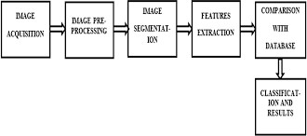

* 1. **Hardware/Software Design :**

Deep learning is the latest trend in machine learning, which has already boosted the performance in many nonmedical areas. Deep learning can be seen as an extension of the well-known multilayer neural network classiﬁers trained with

back-propagation, except that many more layers are used. There are also different kind of layers that are used in typical successions. Deep learning typically requires large

training sets. This is the reason why medical applications have been among the last applications to adopt deep learning, as annotated training images are signiﬁcantly harder to obtain because of expert knowledge requirements and privacy concerns. The ﬁrst article to apply deep learning to malaria diagnosis is by Liang et al.,[51](https://www.sciencedirect.com/science/article/pii/S193152441730333X#bib0260) who use a convolutional neural network to discriminate between infected and uninfected cells in thin [blood smears](https://www.sciencedirect.com/topics/medicine-and-dentistry/blood-smear), after applying a conventional level-set cell segmentation approach. This is an ideal application for deep learning because images of segmented red blood cells are a natural input for a convolutional neural network. Deep learning does not

require the design of handcrafted features, which is one of its biggest advantages.

The current gold-standard method for malaria diagnosis in the ﬁeld is light microscopy of blood ﬁlms, which is the main focus of this article. Although other forms of diagnosis exist and have become popular in recent years, in particular RDTs, microscopy remains the most popular diagnostic tool, especially in resource-poor settings. With microscopy, all parasite species can be detected. It allows computing the level of parasitemia, clearing a patient after a successful treatment, and monitoring drug resistance.

Furthermore, it is less expensive than other methods and widely available.

However, its biggest disadvantages are the extensive training required for a microscopist to become a proﬁcient malaria slide reader, the high cost of training and employing, maintaining skills, and the large component of manual work involved.

To diagnose malaria under a microscope, a drop of the patient's blood is applied to a glass slide, which is then immersed in a staining solution to make parasites more easily visible under a conventional light microscope, usually with a 100× oil objective.

Two different types of [blood smears](https://www.sciencedirect.com/topics/medicine-and-dentistry/blood-smear) are typically prepared for malaria diagnosis: thick and thin smears.

A thick smear is used to detect the presence of parasites in a drop of blood.

Thick smears allow a more eﬃcient detection of parasites than thin smears, with an 11 times higher sensitivity. On the other hand, thin smears, which are the result of

spreading the drop of blood across the glass slide, have other advantages. They allow the examiner to identify malaria species and recognize parasite stages more easily.

The actual microscopic examination of a single blood slide, including

quantitative parasite detection and species identiﬁcation, takes a trained microscopist 15–30 minutes. Considering that hundreds of thousands of blood slides are manually inspected for malaria every year, this amounts to a huge economic effort required for malaria diagnosis.

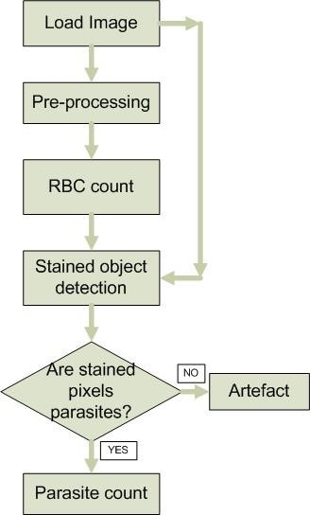

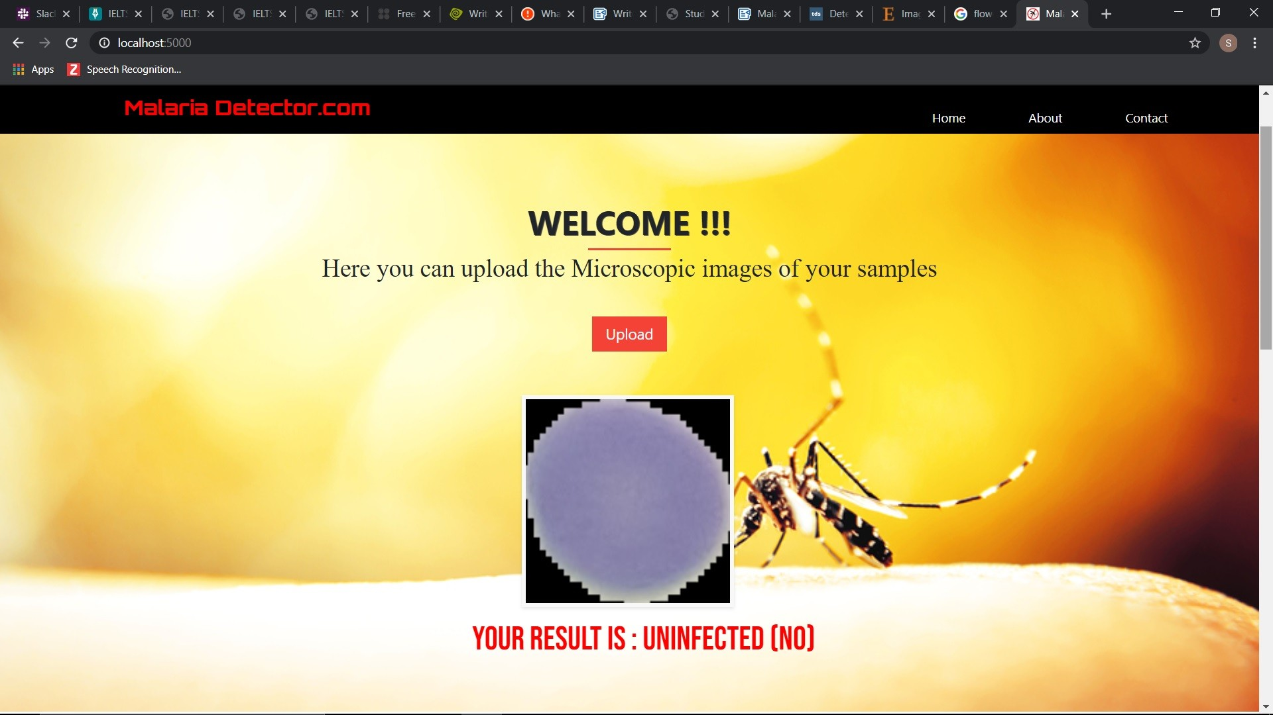

 it robust enough to understand and use novel data, but most data scientists have learned to control the learning to focus on what’s important to them.

 it allows us to teach a speciﬁc task rather than teaching the system how to learn.

We can use different examples to train a particular model or we can use a very simple training set and simply ask it to learn.

 it can become any kind of system. It can be for one thing, such as just a face recognition, or for another, such as an image reconstruction. It can be with a large number of weights, or with a very small number. It can be linear or nonlinear.

 it handles everything at a much higher level of abstraction than your standard neural network, so the training process is, at its core, much less complex.

 it can go and get a new image from its own memory.

 it is not affected by computation power. Hence, it can gain insights much more quickly and thus, it can tackle problems that are traditionally tricky to solve.

 it allows us to study the world as a non-supervised structure. If you look at neurons, they have such varied functions and shapes.

## DISADVANTAGES :

 it’s not 100% eﬃcient and it will have some diﬃcult problems.

 it requires huge data sets in order to train. They can be huge, especially when you consider that we only know the image and not the context.

 it is very hard to understand. Thus, deep learning is the next step in machine learning. It allows machines to be more and more sophisticated by learning something more about the world, and then be able to draw a generalization from this knowledge and in the future apply it to another problem.

 it requires to train the model to learn about deep structures, a process which requires billions of hours of computation in a highly parallel computer architecture.

 Self Driving Cars

 News Aggregation and Fraud News Detection  Natural Language Processing

 Virtual Assistants  Entertainment

 Visual Recognition  Fraud Detection

 Healthcare

 Personalisation

 Detecting Developmental Delay in Children

## 9.CONCLUSION :

We looked at an interesting real-world medical imaging case study of malaria detection in this article.

Malaria detection by itself is not an easy procedure and the availability of the right personnel across the globe is also a serious concern.

We looked at easy to build open-source techniques leveraging AI which can give us state-of-the-art accuracy in detecting malaria thus enabling AI for social good.

I encourage everyone to check out the articles and research papers mentioned in this article, without which it would have been impossible for me to conceptualize and write this article.

Let’s hope for more adoption of open-source AI capabilities across healthcare making it cheaper and accessible for everyone across the world!

 This application will have additional features to detect other diseases which are spreading by mosquitos.

We can ﬁnd patient condition by using mobile itself.

## 11. BIBILOGRAPHY :

### WHOMalaria microscopy quality assurance manual-version 2

World Health Organization (2016)

[Google Scholar](https://scholar.google.com/scholar_lookup?title=Malaria%20microscopy%20quality%20assurance%20manual-version%202&amp;publication_year=2016&amp;author=WHO)

### WHOWorld malaria report 2016

World Health Organization (2016)

[Google Scholar](https://scholar.google.com/scholar_lookup?title=World%20malaria%20report%202016&amp;publication_year=2016&amp;author=WHO)

F.B. Tek, A.G. Dempster, I. Kale**Computer vision for microscopy diagnosis of malaria**

Malar J, 8 (2009), p. 153

[Google Scholar](https://scholar.google.com/scholar_lookup?title=Computer%20vision%20for%20microscopy%20diagnosis%20of%20malaria&amp;publication_year=2009&amp;author=F.B.%20Tek&amp;author=A.G.%20Dempster&amp;author=I.%20Kale)

D. Das, R. Mukherjee, C. Chakraborty**Computational microscopic imaging for malaria parasite detection: a systematic review**

J Microsc, 260 (2015), pp. 1-19

[CrossRef](https://doi.org/10.1111/jmi.12270)[View Record in Scopus](https://www.scopus.com/inward/record.url?eid=2-s2.0-84941599019&amp;partnerID=10&amp;rel=R3.0.0)[Google Scholar](https://scholar.google.com/scholar_lookup?title=Computational%20microscopic%20imaging%20for%20malaria%20parasite%20detection%3A%20a%20systematic%20review&amp;publication_year=2015&amp;author=D.%20Das&amp;author=R.%20Mukherjee&amp;author=C.%20Chakraborty)

**SOURCE CODE :**

## MODEL FILE :

from keras.models import Sequential

from keras.layers import Convolution2D from keras.layers import MaxPooling2D from keras.layers import Dense

from keras.layers import Flatten

from keras.preprocessing.image import ImageDataGenerator

train_data=ImageDataGenerator(rescale=1./255,shear_range=0.2,zoom_range=0.2,horiz ontal_ﬂip=True)

test_data=ImageDataGenerator(rescale=1./255)

x_train=train_data.ﬂow_from_directory(r"C:\Users\91824\Desktop\june10ai\Malaria Project\train_data",target_size=(64,64),batch_size=32)

x_test=train_data.ﬂow_from_directory(r"C:\Users\91824\Desktop\june10ai\Malaria Project\test_data",target_size=(64,64),batch_size=32)

model=Sequential() model.add(Convolution2D(32,(3,3),input_shape=(64,64,3),activation="relu")) model.add(MaxPooling2D(pool_size=(2,2)))

model.add(Flatten())

model.add (Dense(units=128 , init="random_uniform", activation="relu")) model.add (Dense(units=64 , init="random_uniform", activation="relu")) model.add (Dense(units=64 , init="random_uniform", activation="relu")) model.add (Dense(units=64 , init="random_uniform", activation="relu")) model.add (Dense(units=2, init="random_uniform", activation="sigmoid"))

model.compile(loss="binary_crossentropy",optimizer="adam",metrics=["accuracy"]) model.ﬁt_generator(x_train,steps_per_epoch=32,epochs=20,validation_data=x_test,valid ation_steps=216)

model.save("Malaria_detection.h5")

## MALARIA DETECTION USING DEEP LEARNING :

import numpy as np import os

from keras.models import load_model from keras.preprocessing import image import tensorﬂow as tf

global graph

graph = tf.get_default_graph()

from ﬂask import Flask , request, render_template from werkzeug.utils import secure_ﬁlename

from gevent.pywsgi import WSGIServer

app = Flask( name )

model = load_model("Malaria_detection.h5")

@app.route('/') def index():

return render_template('base.html')

@app.route('/predict',methods = ['GET','POST']) def upload():

if request.method == 'POST': f = request.ﬁles['image']

print("current path")

basepath = os.path.dirname( ﬁle ) print("current path", basepath)

ﬁlepath = os.path.join(basepath,'uploads',f.ﬁlename) print("upload folder is ", ﬁlepath)

f.save(ﬁlepath)

img = image.load_img(ﬁlepath,target_size = (64,64)) x = image.img_to_array(img)

x = np.expand_dims(x,axis =0) with graph.as_default():

preds = model.predict_classes(x) print("prediction",preds)

index = ["Parasitized (YES)","Uninfected (NO)"] text =str("Your Result is : "+index[preds[0]])

return text

if name == ' main ':

app.run(debug = True, threaded = False)

# THANK YOU